Digimatic Analyse für Handmessgeräte:

1. Protokoll Beschreibung

(Dokumente: „***99MAB045A.pdf“, „Ba_3723295_DK-U-D_de_en_fr_es_it_zh_0322-1.pdf“***)

Ein Bild, das Tisch enthält.

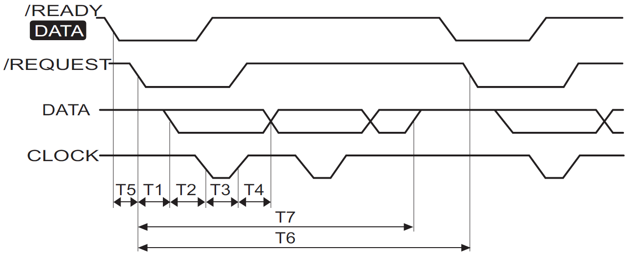

1. Geräte mit 4-polligen Digimatic Kabel, Art. ***4102915*** (4102411)

|  |  |  |  |  |  |  |
| --- | --- | --- | --- | --- | --- | --- |
| **Gerät** | **T1 [ms]** | **T2 [µs]** | **T3 [µs]** | **T4 [µs]** | **T6 [ms]** | **T7 [ms]** |
| 18/25EWR | 200 | 112 | 104 | 136 | 450 | 216 |
| MarCator 1075R, 16/30 EWR | 166 | 112 | 104 | 136 | 150 | 183 |
| MarCator 108(6/7) (B)R | 165 | 112 | 104 | 119 | 150 | 181 |

1. Geräte mit 5-polligen Digimatic Kabel DK-D1, Art. ***4102606***.

|  |  |  |  |  |  |  |
| --- | --- | --- | --- | --- | --- | --- |
| **Gerät** | **T1 [ms]** | **T2 [µs]** | **T3 [µs]** | **T4 [µs]** | **T6 [ms]** | **T7 [ms]** |
| Micromar 40EWR(-L) | 0,8 | 21 | 105 | 110 | 1200 | 13 |
| Millimess Touch | 20 | 19 | 106 | 104 | 100 | 22 |
| MarCator Touch *) | 20 | 19 | 106 | 105 | 90 | 32 |
| C1202 | 0,005 | 6 | 70 | 60 | 10 | 7,4 |

*) Prototyp

1. Geräte runden 4-polligen Digimatic Kabel 2000 d, Art. ***4346021***.

|  |  |  |  |  |  |  |
| --- | --- | --- | --- | --- | --- | --- |
| **Gerät** | **T1 [ms]** | **T2 [µs]** | **T3 [µs]** | **T4 [µs]** | **T6 [ms]** | **T7 [ms]** |
| C1200 | 35 | 71 | 105 | 97 | 70 | 49 |